Monte-Carlo Simulations with CASINO - results

- calculate for Cu, Si and C as target materials and perpendicular incidence:
  - the penetration depth of 30keV, 15keV, 5keV, 1.5keV electrons
 | 30keV | 15keV | 5keV | 1.5keV
Cu | ~ 2μm | ~ 500nm | ~ 90nm | ~ 20nm
Si | ~ 7μm | ~ 2μm | ~ 300nm | ~ 50nm
C | ~ 6.5μm | ~ 1.7μm | ~ 250nm | ~ 35nm

  - observe the escape depth of backscattered electrons (BSE), same energies
 | 30keV | 15keV | 5keV | 1.5keV
Cu | ~ 800nm | ~ 300nm | ~ 43nm | ~ 9nm
Si | ~ 2.3μm | ~ 700nm | ~ 150nm | ~ 20nm
C | ~ 2μm | ~ 500μm | ~ 90nm | ~ 10nm

  - observe the backscattering coefficient (at bottom of the program window)
 | 30keV | 15keV | 5keV | 1.5keV
Cu | 0.28 | 0.301 | 0.27 | 0.302
Si | 0.156 | 0.139 | 0.156 | 0.175
C | 0.042 | 0.038 | 0.043 | 0.056

Cu 30kV | Cu 15kV
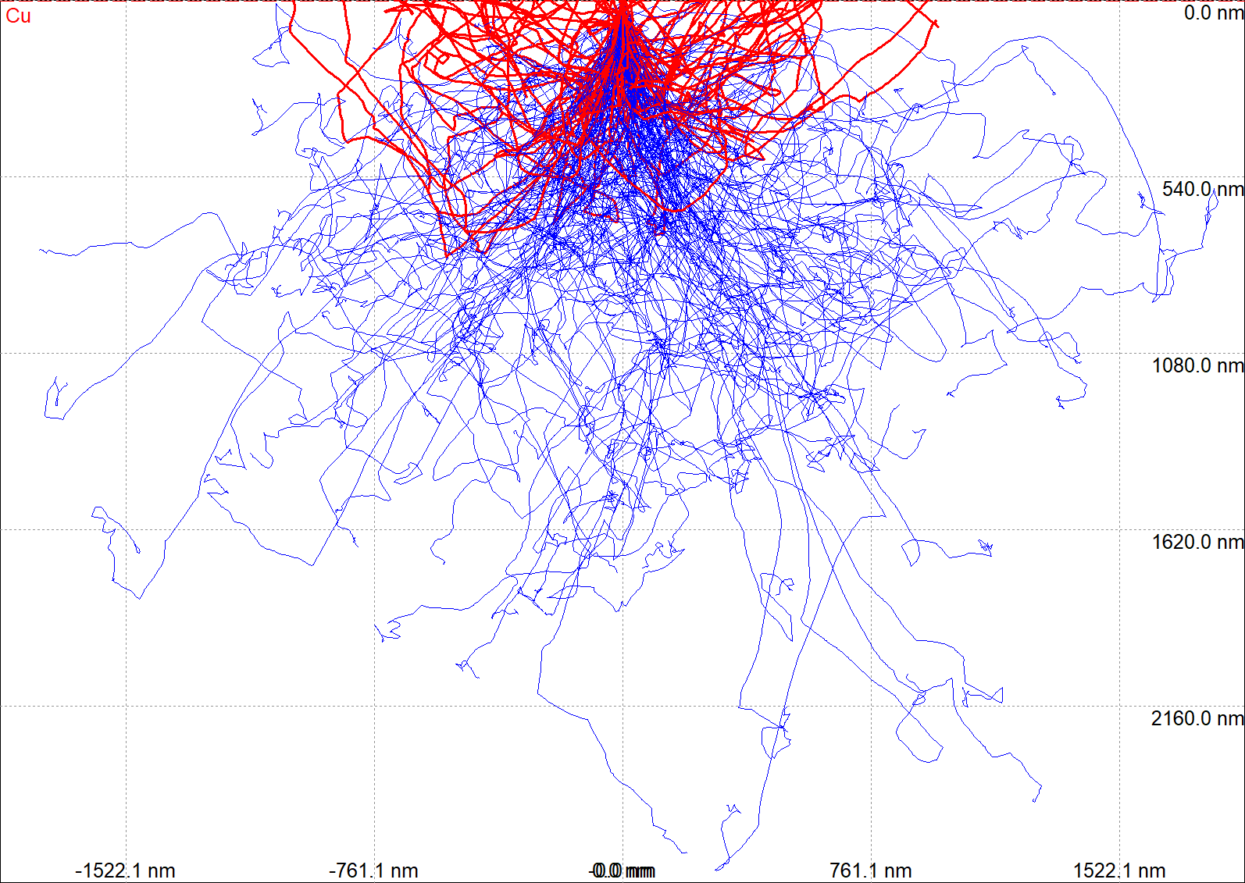 | 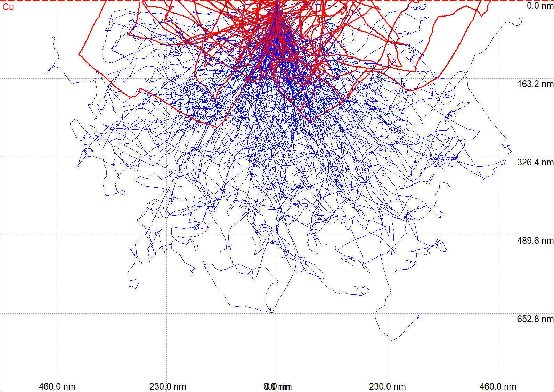
Cu 5kV | Cu 1.5kV
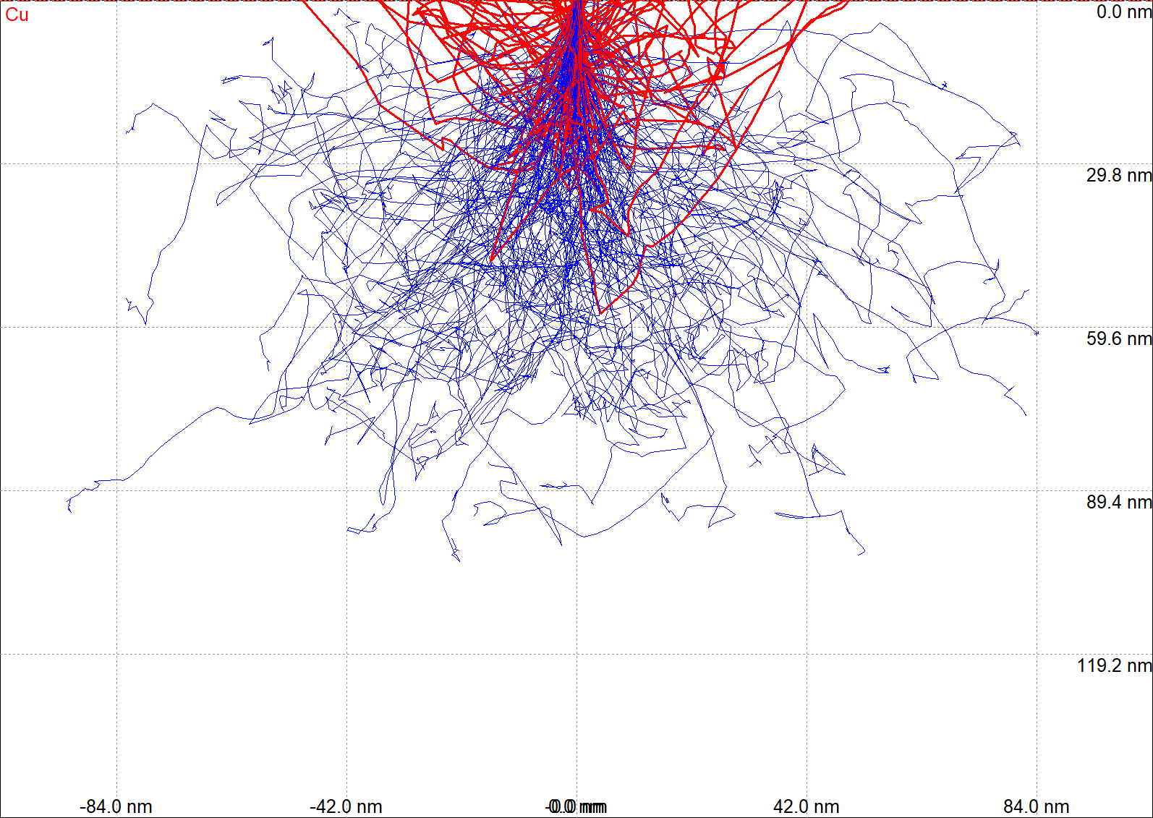 | 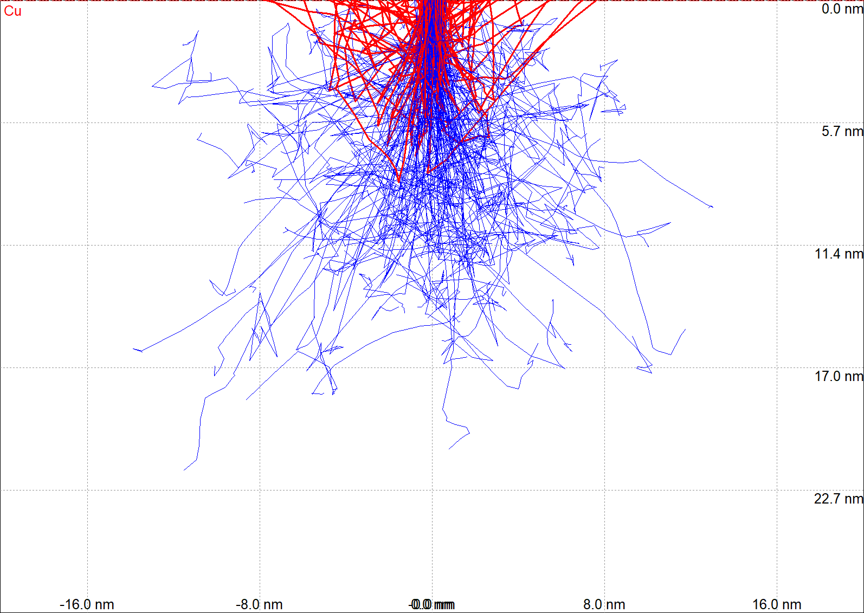
Si 30kV | Si 15kV
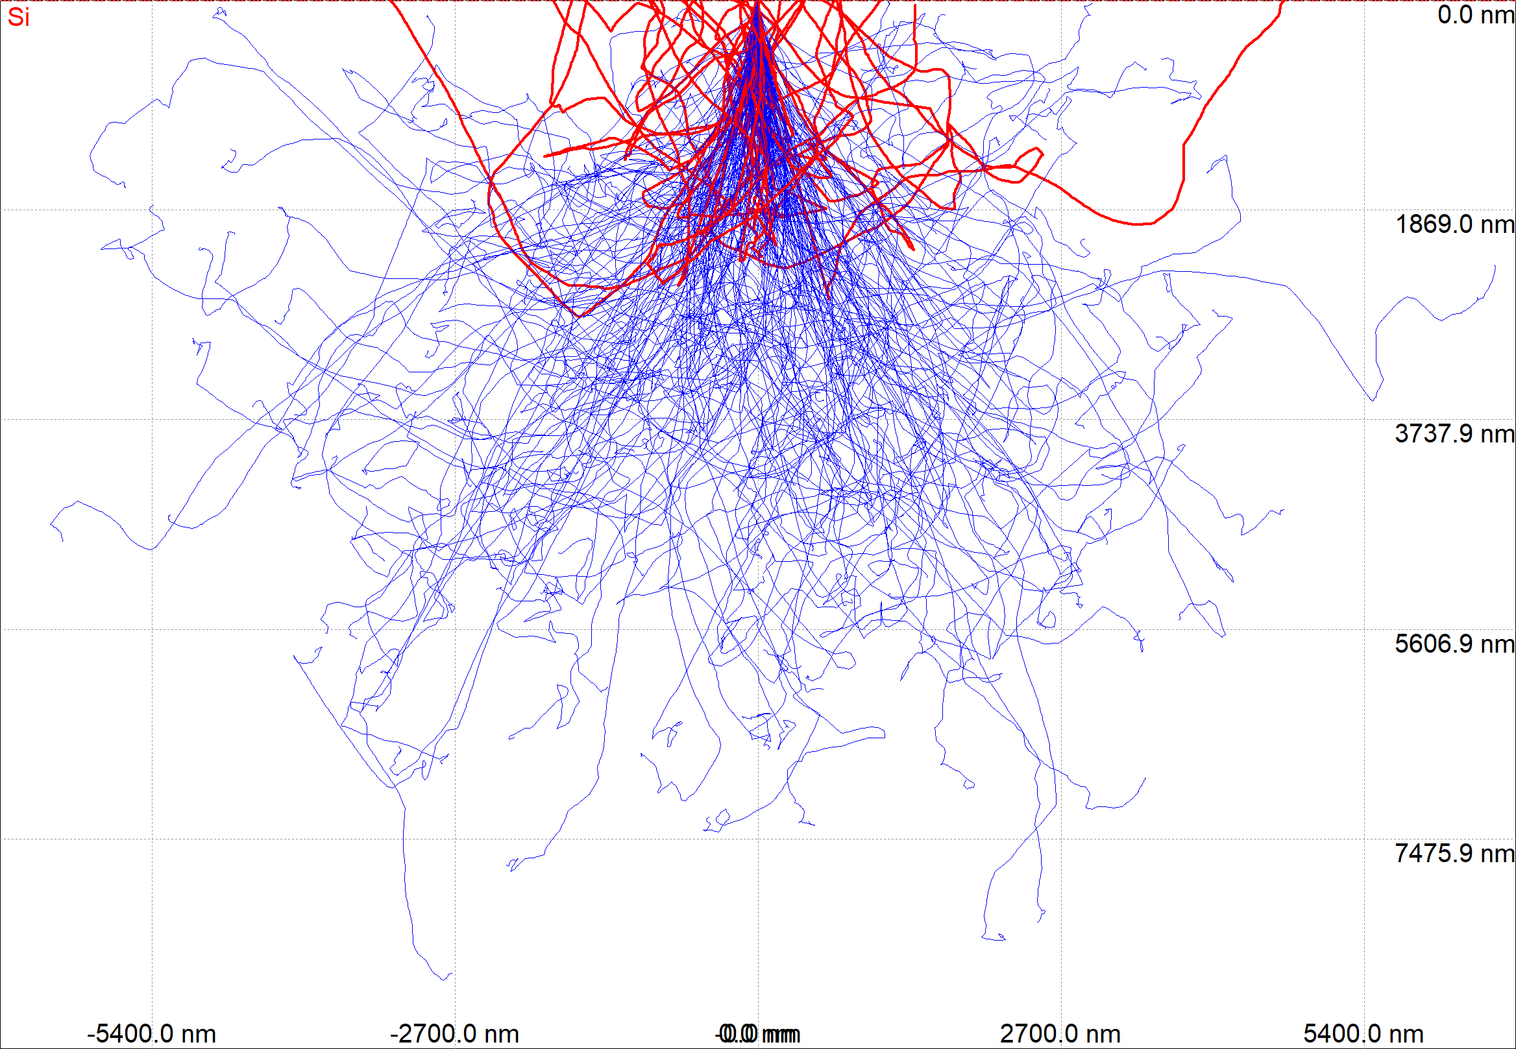 | 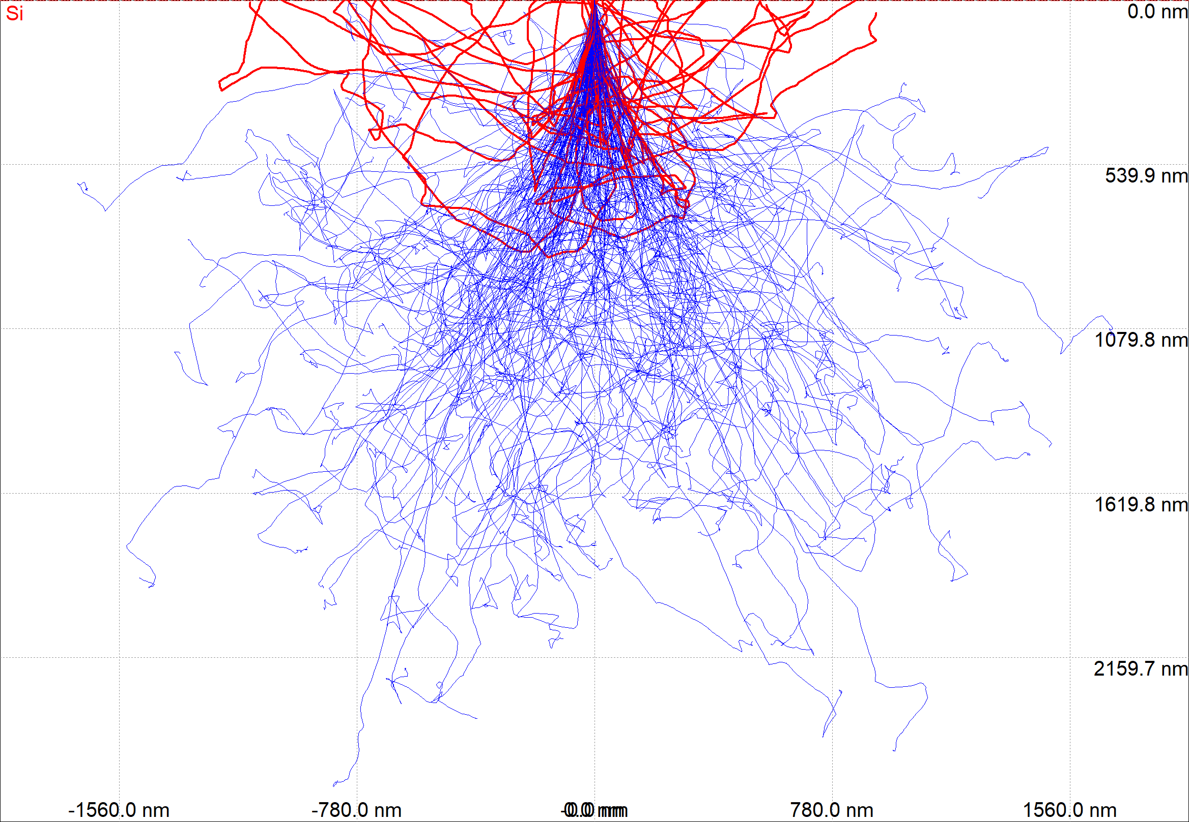
Si 5kV | Si 1.5kV
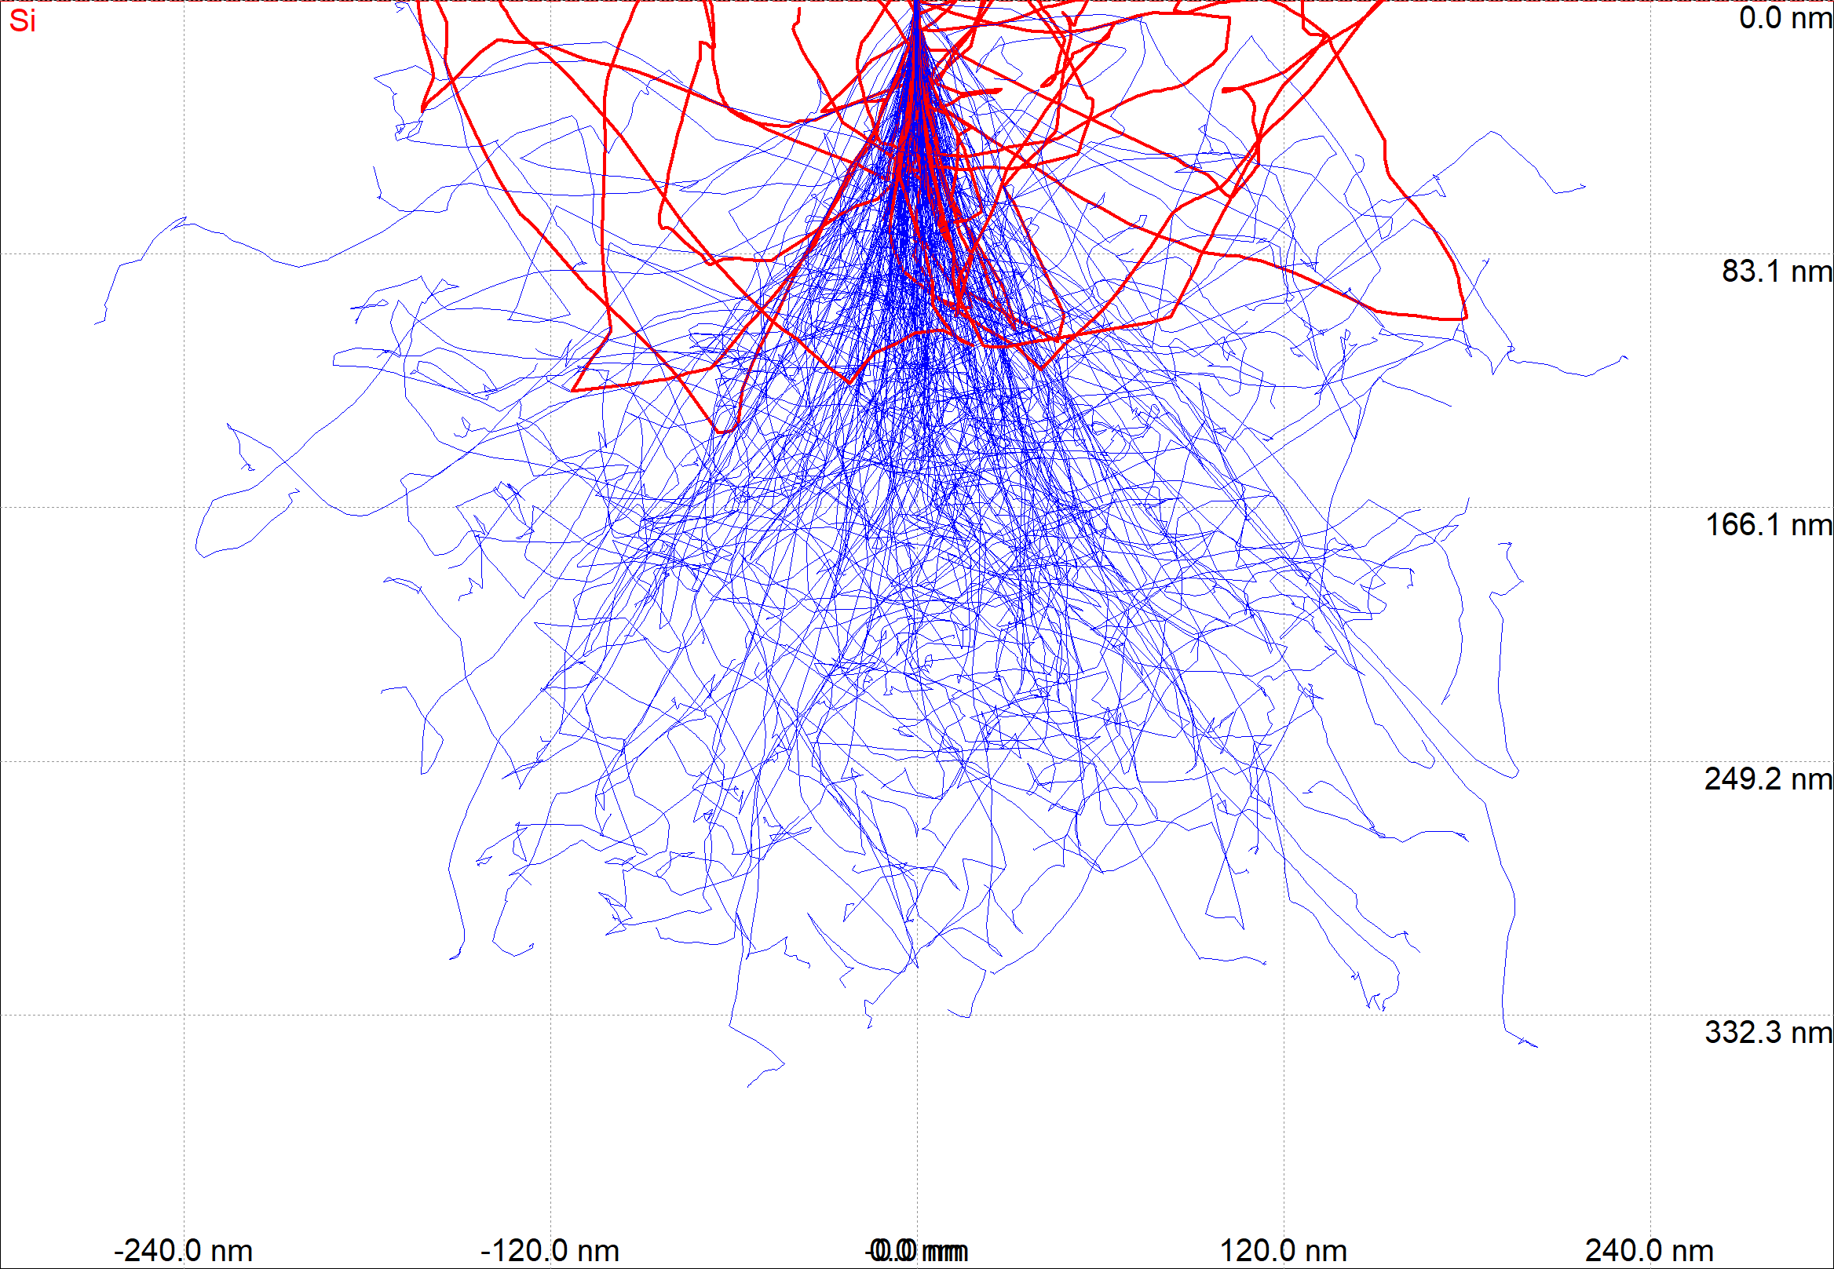 | 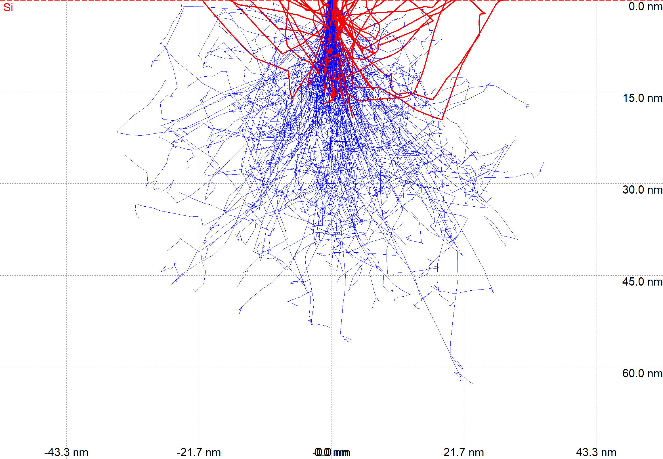
C 30kV | C 15kV
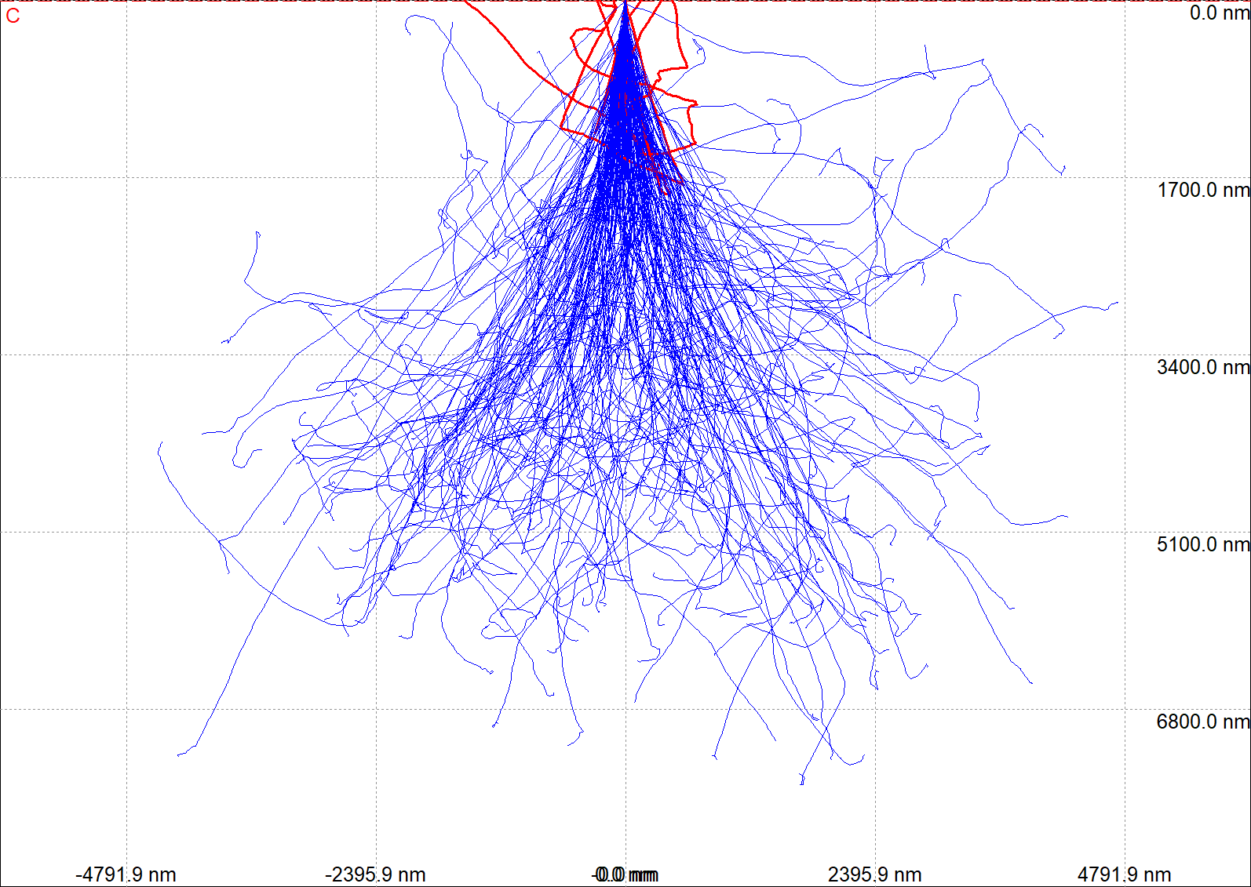 | 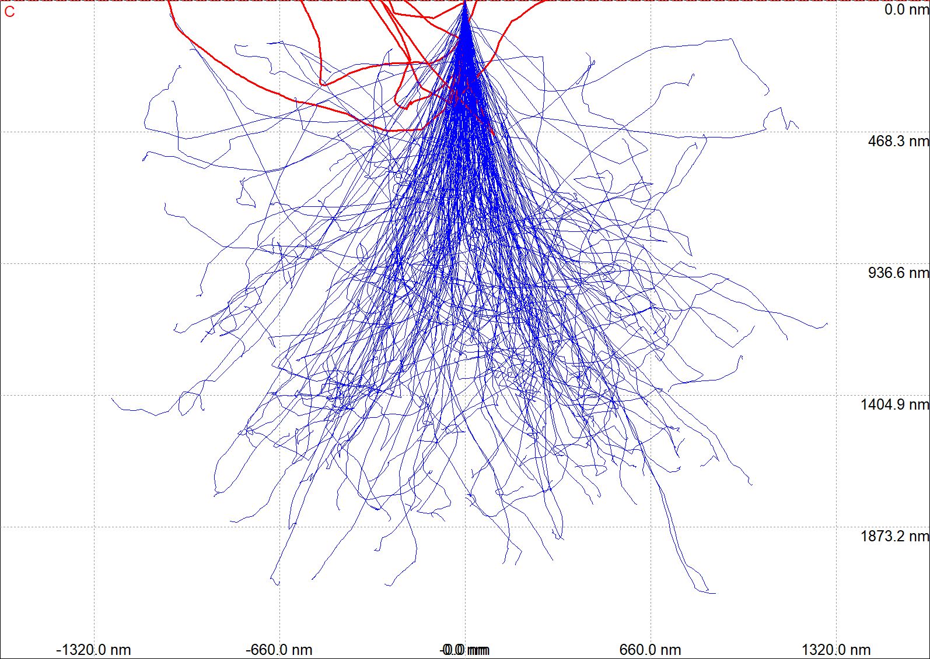
C 5kV | C 1.5kV
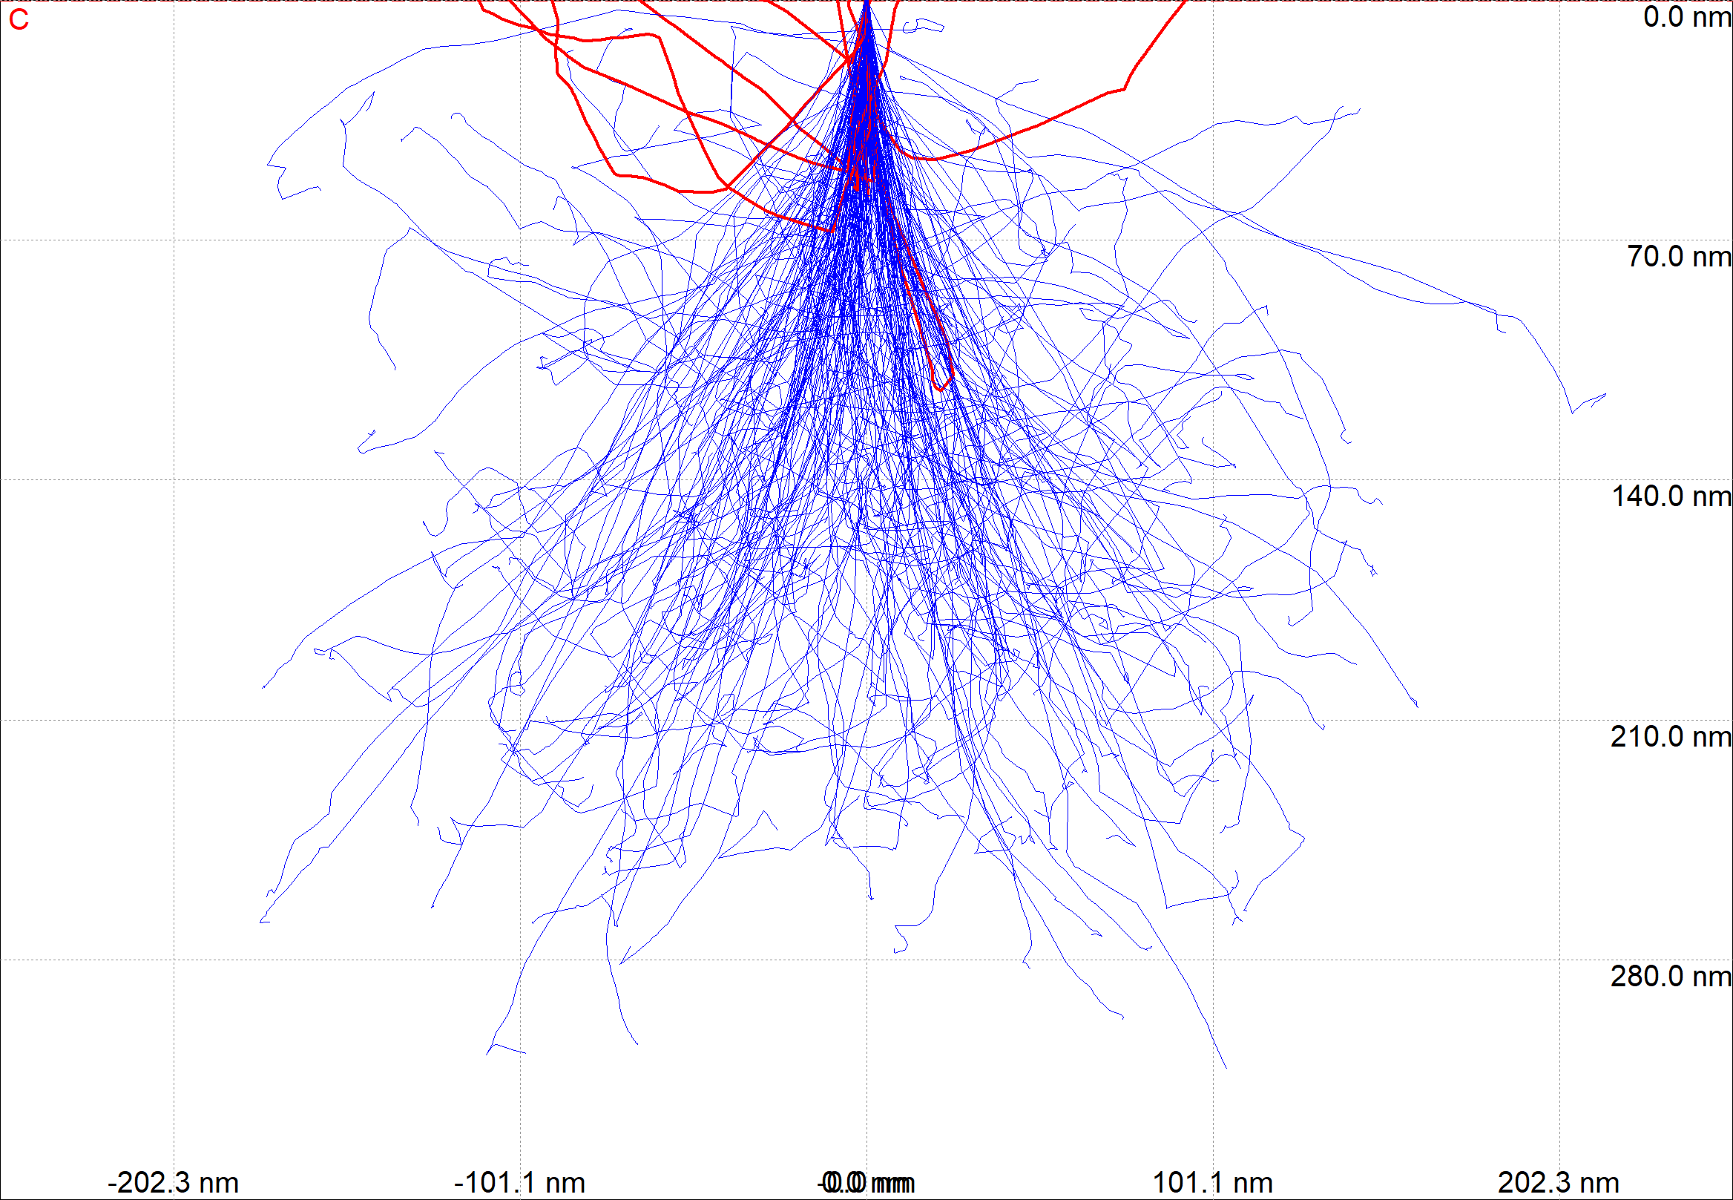 | 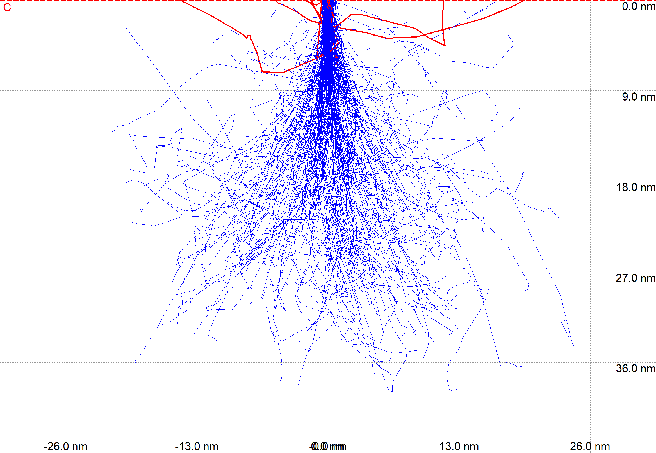

2) simulate BSE profile across a grain boundary Al/Zn for 10keV, 5keV, 2keV
- estimate the resolution limit for a sharp interface and a beam diameter of 3nm
- optional: calculate the X-ray emission profile for a line scan across a grain boundary for 15keV. Al-K 1.48keV, Zn-L 1.0118keV: which Energy would be most suitable to get the highest spatial resolution (calculate profiles)

10kV | 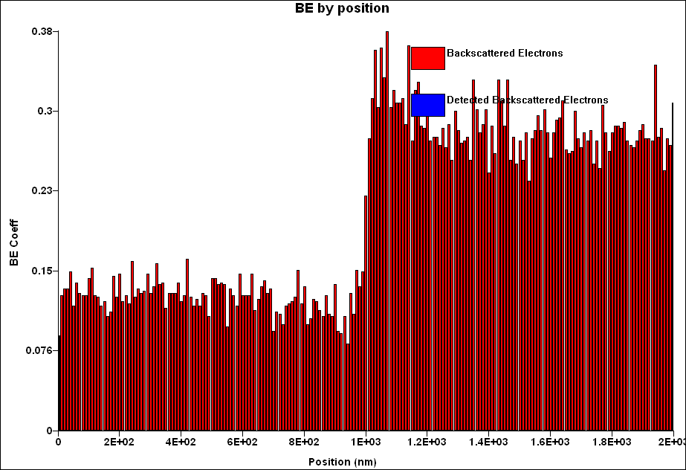
5kV | 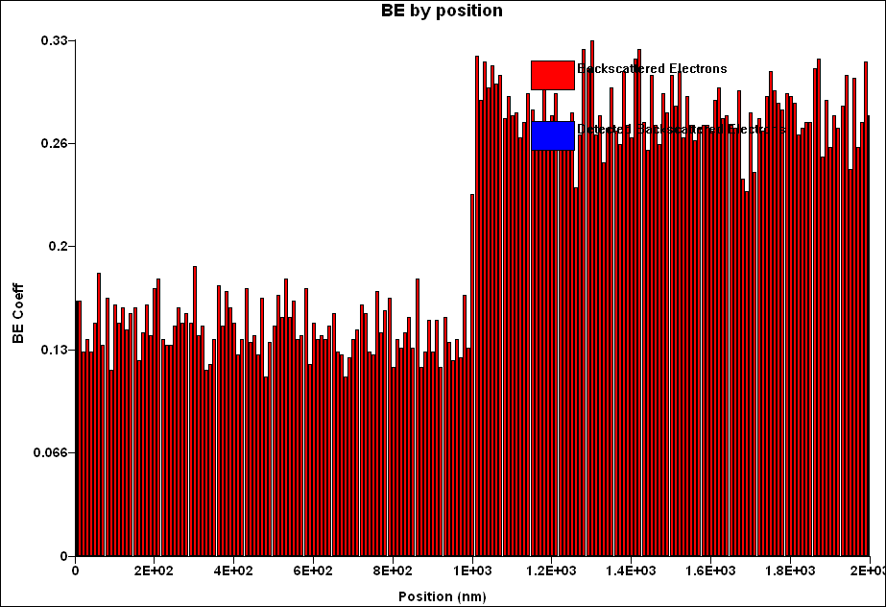
2kV | 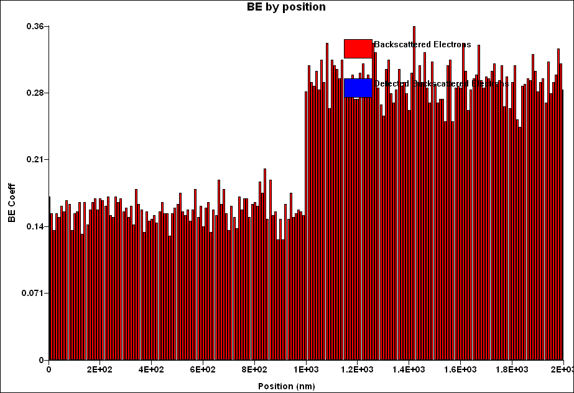

Al/Zn 15keV | Al/Zn 10keV
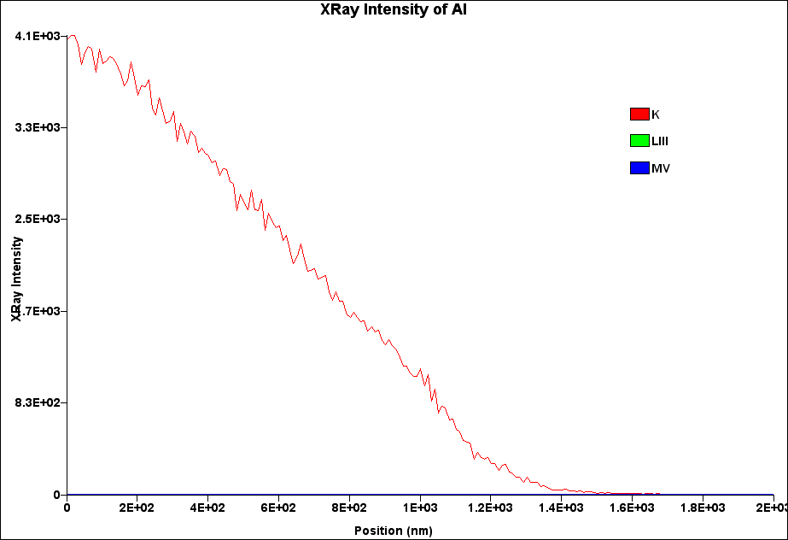 | 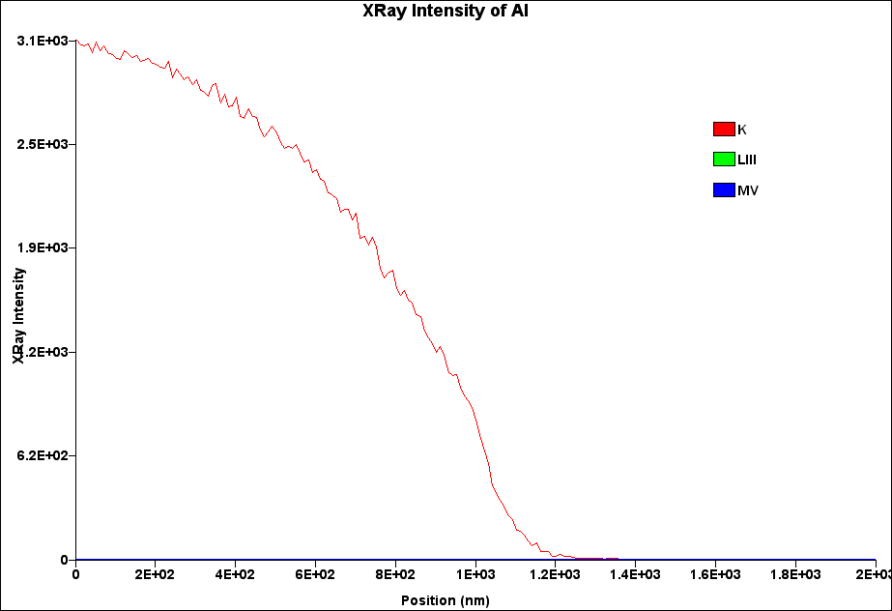
Al/Zn 5keV | Al/Zn 2keV – the highest spatial resolution
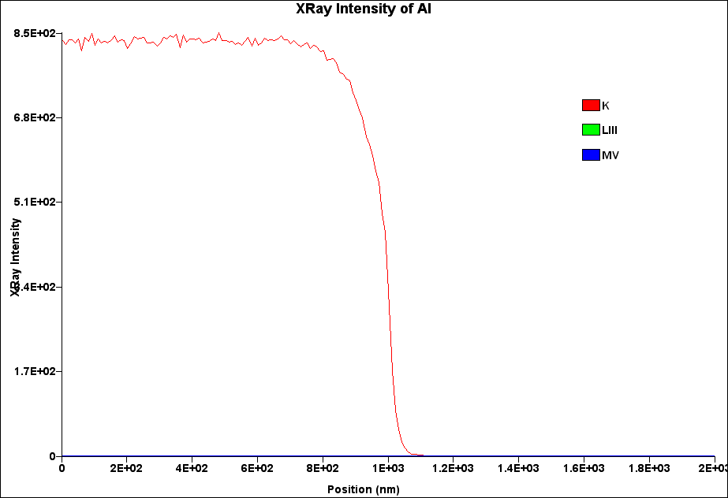 | 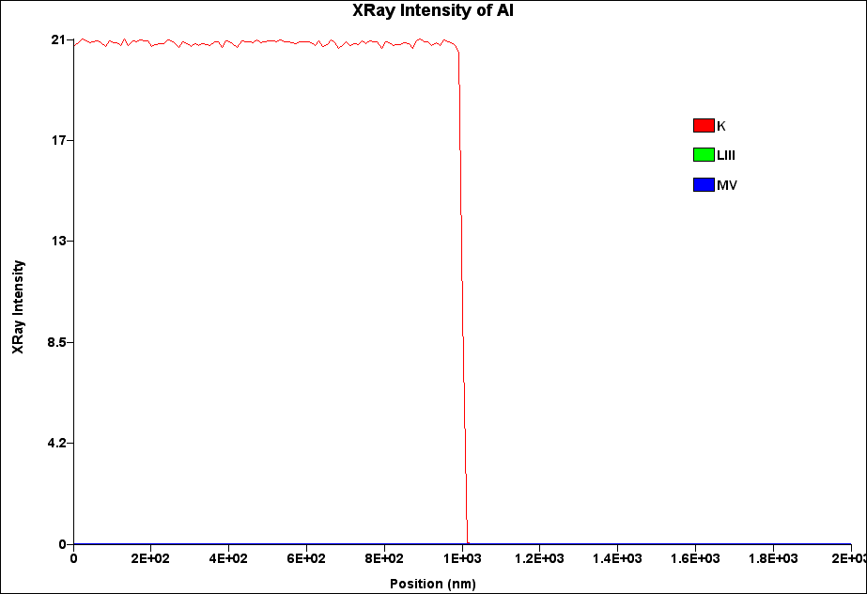
Al/Zn 15keV | Al/Zn 10keV
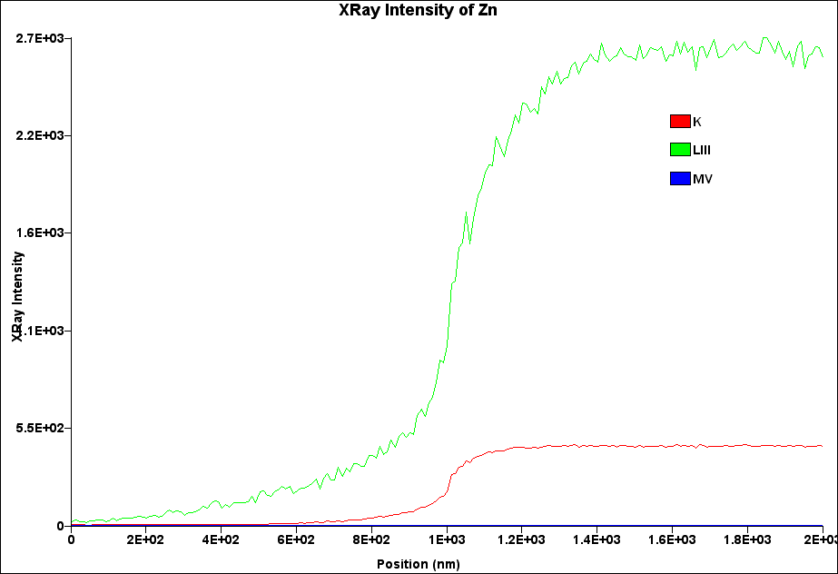 | 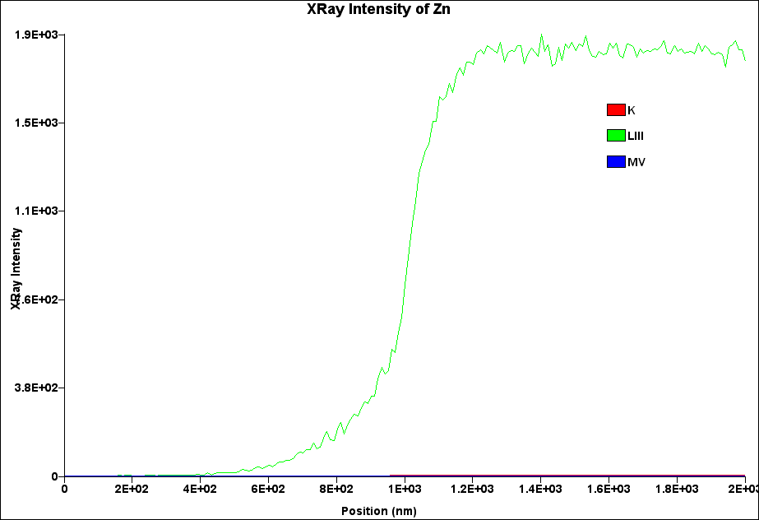
Al/Zn 5keV | Al/Zn 2keV – the highest spatial resolution
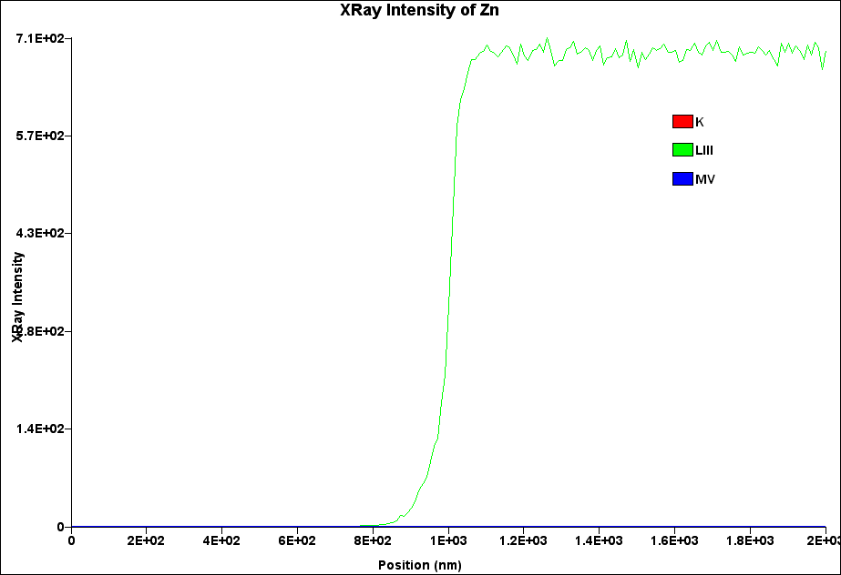 | 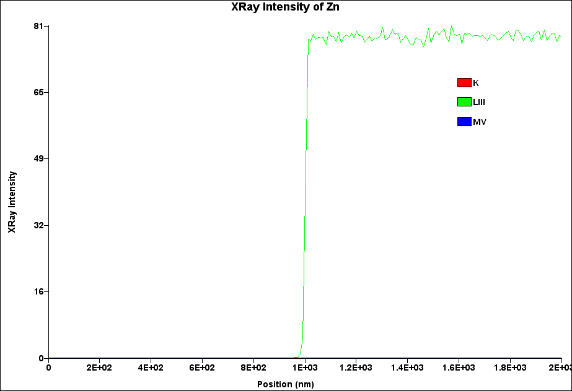

3) simulate X-ray profile across a grain boundary Cu/Nb3Sn for 30keV and for 7 kV
- calculate the X-ray emission profile for a line scan across a grain boundary for 30 keV and 7 keV; which Energy would be most suitable to get the highest spatial resolution (calculate profiles)

Cu/Nb3Sn 30kV
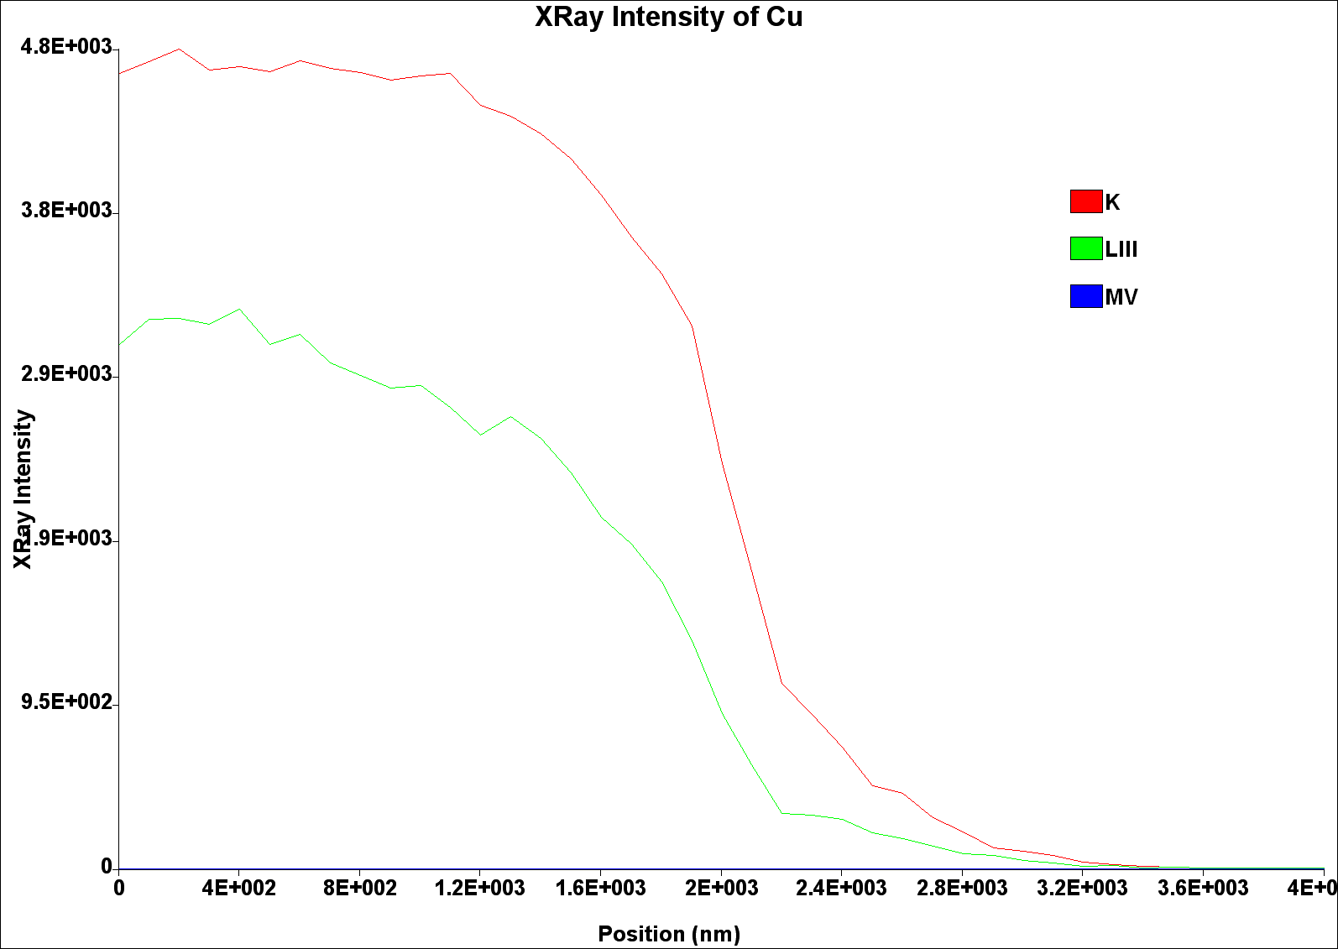
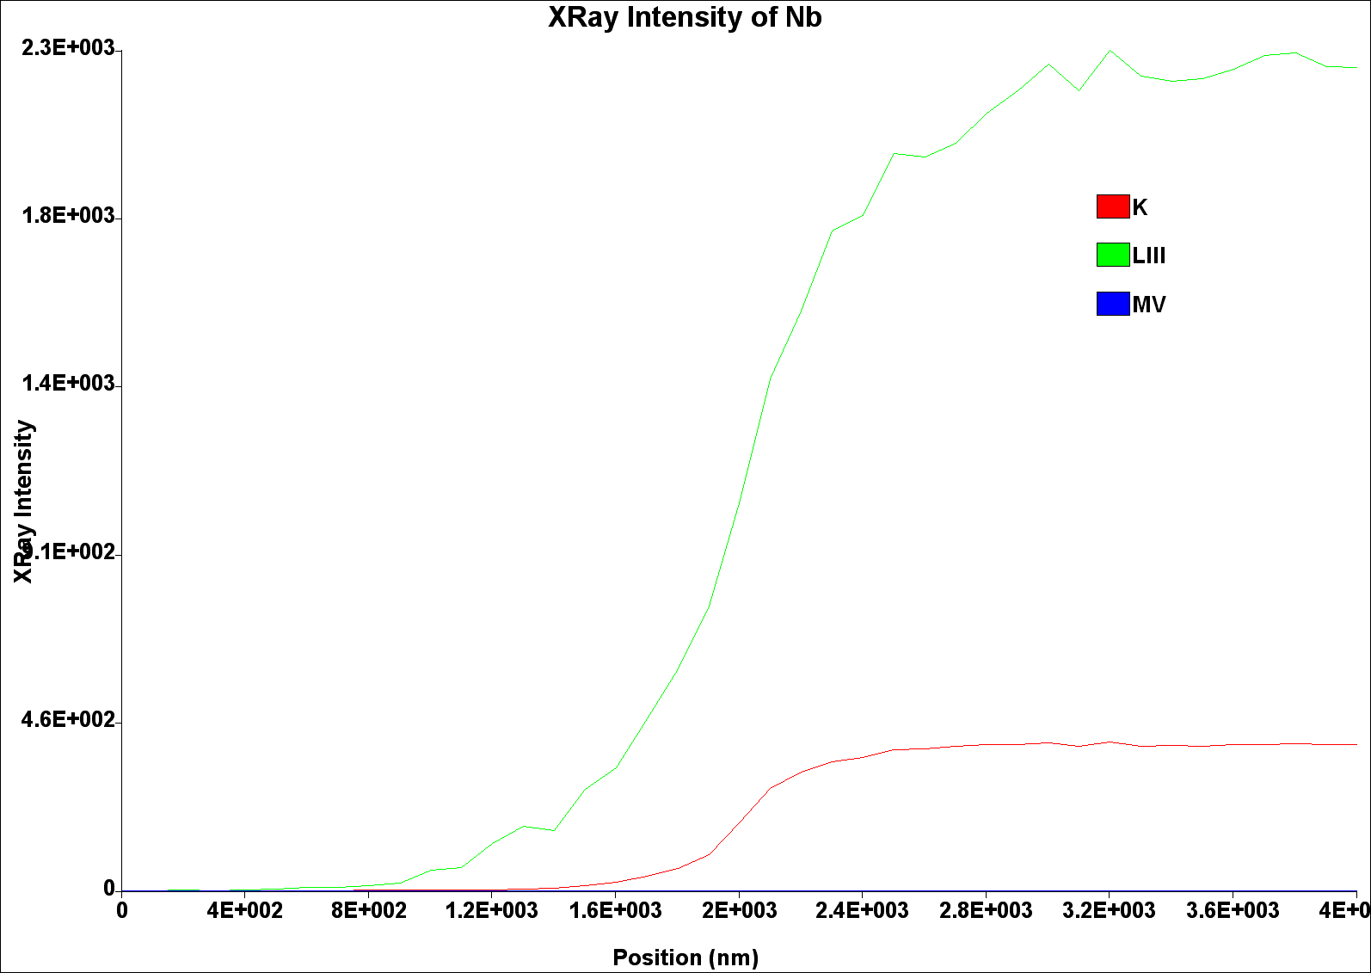
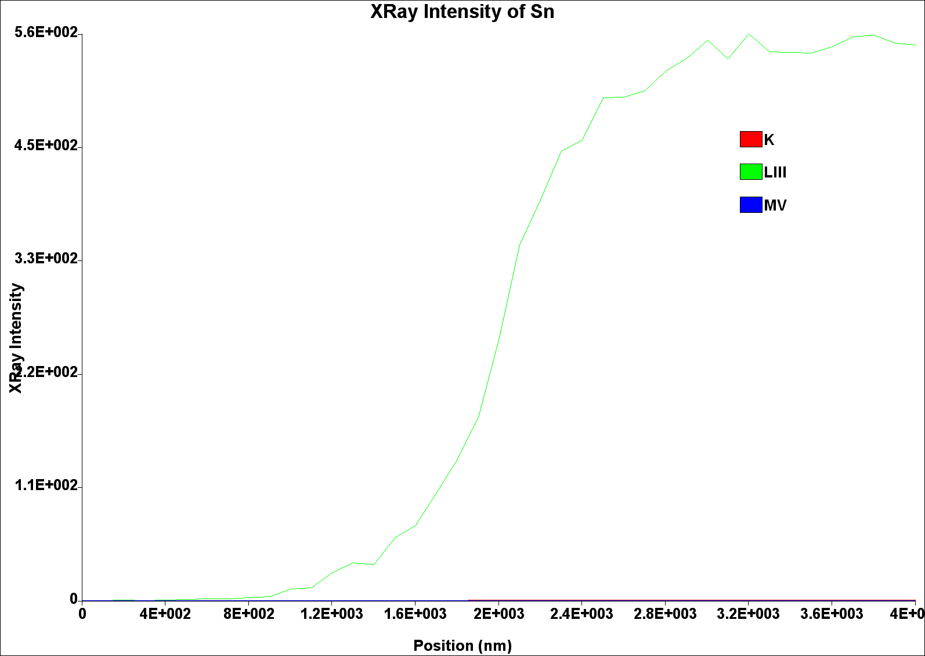
Cu/Nb3Sn 7kV – higher spatial resolution
